NAVEX PROJECTS – AUDIO DEFECTS AND TESTING TIPS

We’ve been approached by Via about some inconsistencies and incorrect practices when testing Navex projects.
The reason for this memo is not to point fingers at anyone specifically. If you’re already implementing these testing tips – great, if not – here’s your chance to get better.
Please read carefully and respond to me that you have read and understood this memo. If you have any questions, feel free to contact me.

- AUDIO DEFECTS

We have been seeing audio issues being reported during the Beta QA round that should have been caught during script review, and at the very latest, during Alpha QA of the course.

The script review was implemented in order to reduce the number of audio defects. Granted that audio quality cannot be verified during script review, any inconsistencies between the source and the target script need to be reported at this stage. Any other audio-related bugs (distorted speech, cutting off, noise etc.) must be reported in Alpha QA. If reported in Beta the client is incurring exorbitant costs to re-create audio and is also missing crucial deadlines.

Our goal is to find issues during script review to avoid re-recording. Please ensure that all audio defects are reported the latest by the Alpha QA stage.

- FONT INCONSISTENCIES

A lot of Navex projects have some words or phrases either bolded, highlighted or in italics. It’s important to mirror it in target languages (unless the translation does not have the English equivalent – in that case it’s sufficient to make a comment in your delivery email so that the client knows font formatting won’t apply).
There is a simple way to make sure these types of issues are caught and reported. Here’s how to do it:
- Open RTF file for the Navex course you’re reviewing
- Type Ctrl F to open a search box
- Type { in the search box – it will pull up all the tags in both source and target that are responsible for font formatting:

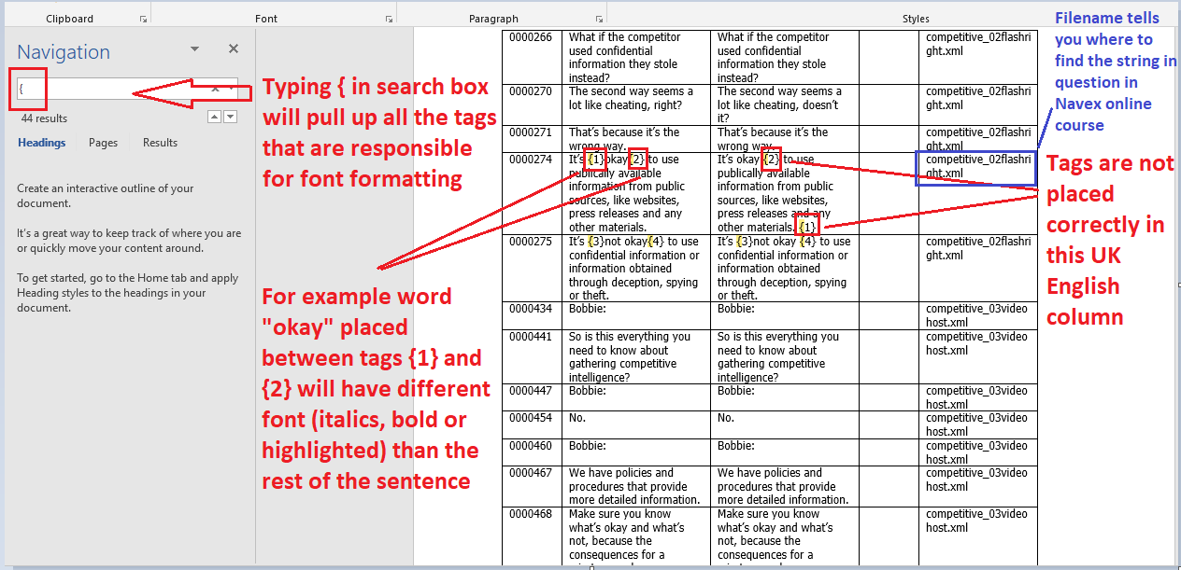

- Compare source with the target to spot any discrepancies
- Use the up and down arrows under the search box to scroll through all tag instances in RTF file
- The last “Filename” column has the name of Navex tab where you can find this issue

- FEWER CATEGORIES IN MANTIS

Moving forward, you will no longer need to add the RTF ID or Steps to Reproduce in Mantis:

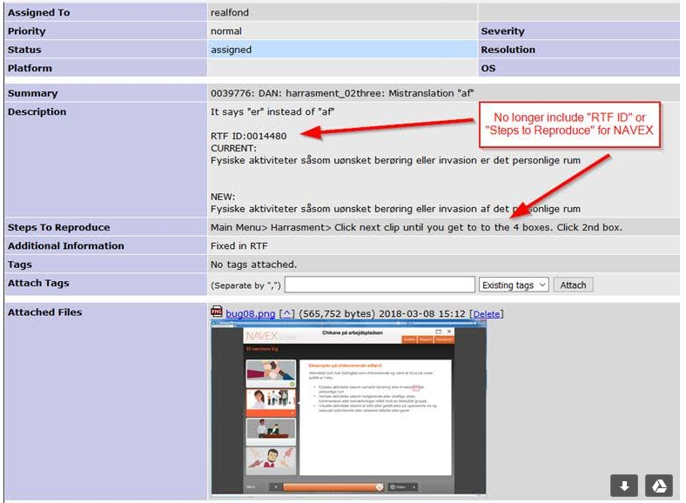

That should speed things along and give you extra testing time.

- PROVIDE COMPLETE INFORMATION IN MANTIS
When reporting bugs in Mantis please make sure that Summary and Description fields are filled out correctly and nothing is missing. Always attach screencaps with marked up issues. See below:

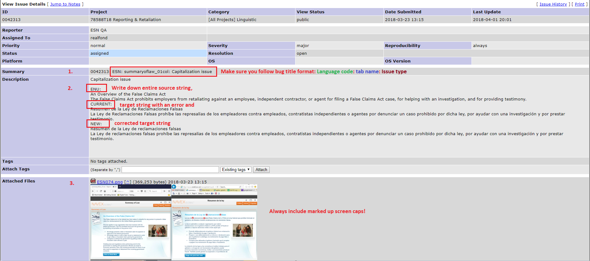

- BETA TESTING
Beta round consists of fix verification and smoke testing (briefly checking the course again for additional issues). Please make sure that apart from verifying if your defects were fixed you also spend some time re-checking the course.

